**WEB BASED CHAT APPLICATION**

Tamil Selvan

PraveenKumar

Mohan Kumar

Yeshwanth

Karan Kumar

Software Requirements Specification

# Product Objective

Building a Web Based Chat Application

# Users of the application

* Public
* Government

# 

# 

# 

# Platforms Used:

* HTML
* SQL
* JAVASCRIPT
* CSS
* Domain

# 

# Functional requirement:

* *· The chat application is a web-based application that allows users to communicate with each other in real-time through text message and multimedia content.*
* *· The chat application provides the following functions:*
  + - *User authentication and authorization*
    - *Chat room creation and management*
    - *Notification and alerts*
    - *User interface design*
* *· The chat application is designed for users of all ages and backgrounds who want to communicate with each other in real-time.*
* *· The chat application can be accessed through a web browser on any device with an internet connection, including desktop computers, laptops, tablets, and smartphones.*
* *· The chat application must be designed and implemented in a way that is compatible with modern web browsers and operating systems.*

# 

# Standard Features:

* User Registration and Authentication
* Real-time Messaging
* User Contacts and Friends List
* Chat Room
* Notifications
* Online Status and Presence
* Profile Customization
* Profile Customization
* Search and Message History
* Security and Privacy

# Non-Functional Requirements:

* + Performance
  + Messages should be delivered within seconds.
  + Scalability to handle a large user base.
  + Security
  + Encryption and secure data transmission.
  + Protection against common security threats.
  + Usability
  + Intuitive user interface.
  + Cross-browser compatibility.
  + Support for multiple languages.
  + Reliability
  + High uptime and availability.
  + Data backup and recovery procedures.

# Browsers Compatible:

* Chrome From Google
* Safari from Apple
* Edge from Microsoft
* Every existing third-party browsers

# Server Requirements:

-**Operating System**: Linux-based ***(e.g., Ubuntu, CentOS)***, but Windows can also be used.

- **Web Server**: Apache, Nginx, or another web server.

- **Database**: MySQL, PostgreSQL, MongoDB, or other suitable databases for storing chat messages and user data.

- **Programming Language**: Choose a language that suits your development team's expertise. Common choices include JavaScript (Node.js), Python (Django, Flask), Ruby (Ruby on Rails), or PHP (Laravel).

- **RAM**: Depending on the expected traffic and complexity, anywhere from 1GB to 16GB or more.

- **CPU**: Dual-core or better, again depending on expected load.

- **Storage**: SSDs are recommended for better performance.

- **Network**: A reliable internet connection with sufficient bandwidth to handle concurrent users.

# Development Environment

-- **IDE (Integrated Development Environment)**: Choose an IDE or code editor that your development team is comfortable with, such as Visual Studio Code, Sublime Text, or JetBrains IDEs.

-**Version Control**: Use a version control system like Git for collaborative development.

# Client Requirement

**-Web Browser**: Ensure compatibility with popular web browsers like Google Chrome, Mozilla Firefox, Safari, and Microsoft Edge.

- **JavaScript**: The chat application will require JavaScript to run on the client side, so make sure it's enabled.

# Security Requirement

- Implement security best practices, including data encryption ***(HTTPS)***, input validation, and user authentication.

- Protect against common web vulnerabilities such as cross-site scripting ***(XSS)*** and cross-site request forgery ***(CSRF).***

* **Mobile Responsiveness:**
  + If you plan to support mobile devices, ensure that your web chat application is responsive and performs well on various screen sizes.
* **Documentation and Maintenance:**
  + Maintain comprehensive documentation for your application's architecture, codebase, and deployment process to facilitate ongoing development and maintenance

**SCREEN SHOTS:**

1. **LOGIN PAGE INTERFACE:**

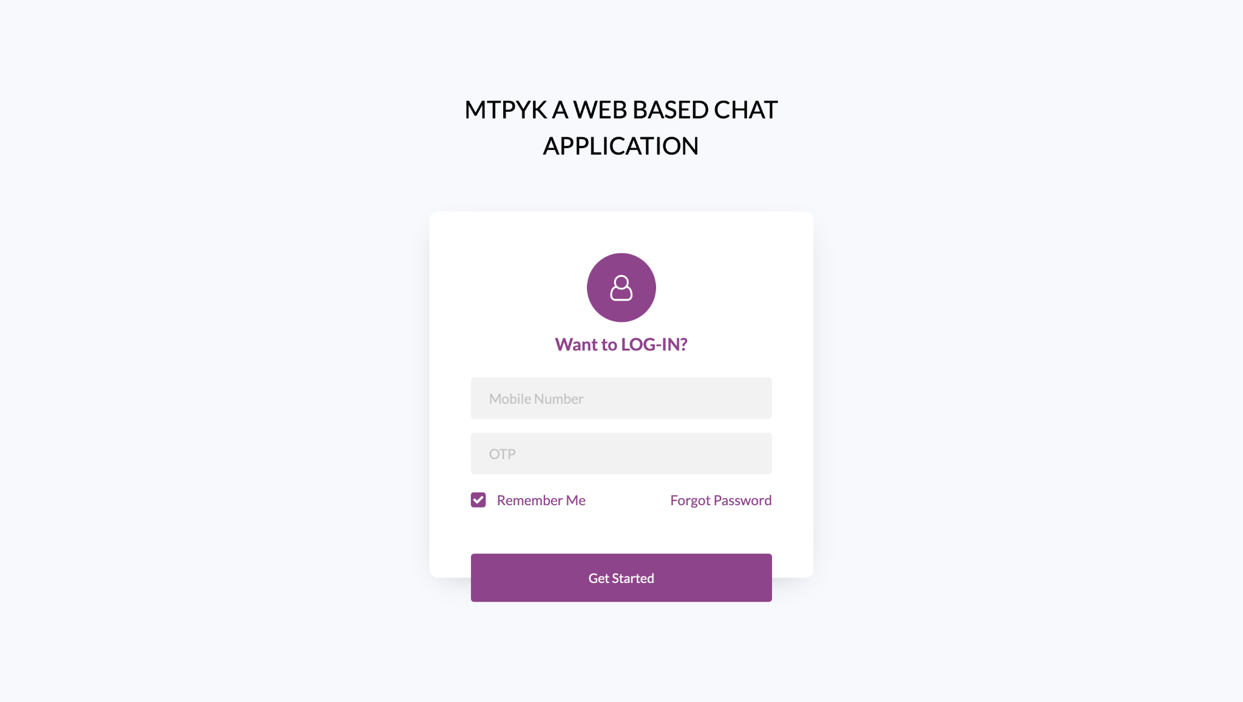

1. **CHAT INTERFACE PAGE:**

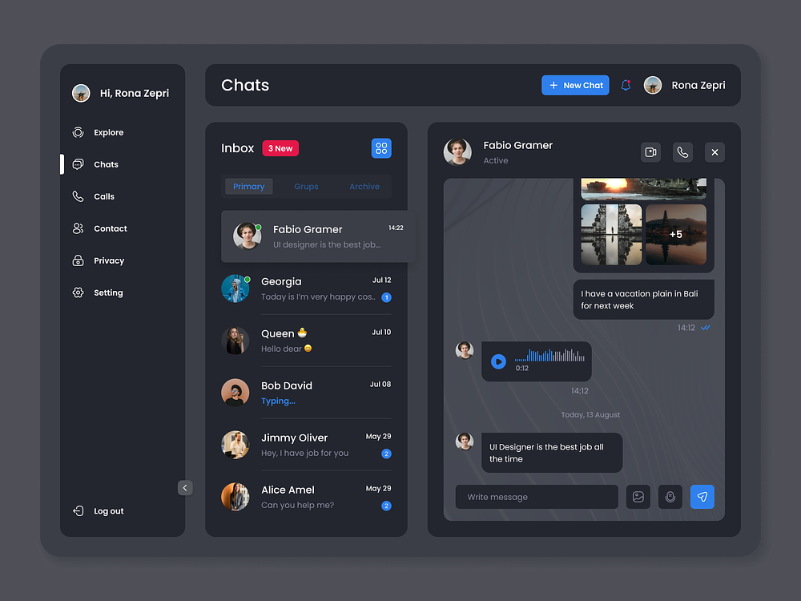

1. **VIDEO CALL INTERFACE:**

